Assignment 01 - CSCI 31022 - Machine Learning and Pattern Recognition

**Student ID : CS/2020/007**

**GitHub Link -** [**https://github.com/AminduBhashana/ML-**](https://github.com/AminduBhashana/ML-Exercises/tree/06693734e5609867cd5c5a3fd931c6b3c1aa8138/Assignment1%20-%20ML%20course%20module)[**Exercises/tree/06693734e5609867cd5c5a3fd931c6b3c1aa8138/Assignment1%20-**](https://github.com/AminduBhashana/ML-Exercises/tree/06693734e5609867cd5c5a3fd931c6b3c1aa8138/Assignment1%20-%20ML%20course%20module)

[**%20ML%20course%20module**](https://github.com/AminduBhashana/ML-Exercises/tree/06693734e5609867cd5c5a3fd931c6b3c1aa8138/Assignment1%20-%20ML%20course%20module)

**Data Set -** [**https://archive.ics.uci.edu/dataset/109/wine**](https://archive.ics.uci.edu/dataset/109/wine)

# import the necessary libraries

**import** pandas **as** pd

**import** numpy **as** np

**import** matplotlib.pyplot **as** plt

**import** seaborn **as** sns

**from** sklearn.preprocessing **import** StandardScaler

**from** sklearn.model_selection **import** train_test_split

**from** sklearn.neighbors **import** KNeighborsClassifier

**from** sklearn.metrics **import** accuracy_score, classification_report, confusion_matrix

In [1]:

# Load the Data Set and identify the data set

url **=** "https://archive.ics.uci.edu/ml/machine-learning-databases/wine/wine.data"

column_names **=** [

"Class", "Alcohol", "Malic_acid", "Ash", "Alcalinity_of_ash", "Magnesium", "Total_phenols", "Flavanoids", "Nonflavanoid_phenols", "Proanthocyanins", "Color_intensity", "Hue", "0D280_0D315_of_diluted_wines", "Proline"

]

df **=** pd**.**read_csv(url, header**=None**, names**=**column_names)

In [2]:

In [3]:

*# Number of data rows and number of feature columns that data set have*

df**.**shape

Out[3]:

In [4]:

*# # print the first 10 rows of the data set*

df**.**head(10)

(178, 14)

|  |  |  |  |  |  |  |  |  |  |
| --- | --- | --- | --- | --- | --- | --- | --- | --- | --- |
| Out[4]: | **Class** | **Alcohol** | **Malic_acid** | **Ash** | **Alcalinity_of_ash** | **Magnesium** | **Total_phenols** | **Flavanoids** | **Nonf** |
|  | **0** 1 | 14.23 | 1.71 | 2.43 | 15.6 | 127 | 2.80 | 3.06 |  |
|  | **1** 1 | 13.20 | 1.78 | 2.14 | 11.2 | 100 | 2.65 | 2.76 |  |
|  | **2** 1 | 13.16 | 2.36 | 2.67 | 18.6 | 101 | 2.80 | 3.24 |  |
|  | **3** 1 | 14.37 | 1.95 | 2.50 | 16.8 | 113 | 3.85 | 3.49 |  |
|  | **4** 1 | 13.24 | 2.59 | 2.87 | 21.0 | 118 | 2.80 | 2.69 |  |
|  | **5** 1 | 14.20 | 1.76 | 2.45 | 15.2 | 112 | 3.27 | 3.39 |  |
|  | **6** 1 | 14.39 | 1.87 | 2.45 | 14.6 | 96 | 2.50 | 2.52 |  |
|  | **7** 1 | 14.06 | 2.15 | 2.61 | 17.6 | 121 | 2.60 | 2.51 |  |
|  | **8** 1 | 14.83 | 1.64 | 2.17 | 14.0 | 97 | 2.80 | 2.98 |  |
|  | **9** 1 | 13.86 | 1.35 | 2.27 | 16.0 | 98 | 2.98 | 3.15 |  |

# Information about the dataset

In [5]:

***# using describe function to get some statistics about dataset***

df.describe()

Out[5]:

**Class Alcohol Malic_acid Ash Alcalinity_of_ash Magnesium Total_phe**

**count 178.000000 178.000000 178.000000 178.000000 178.000000 178.000000 178.000**

**std 0.775035 0.811827 1.117146 0.274344 3.339564 14.282484** **0.625**

**min 1.000000 11.030000 0.740000 1.360000 10.600000 70.000000** **0.980**

**mean 1.938202 13.000618 2.336348 2.366517 19.494944 99.741573** **2.295**

**25% 1.000000 12.362500 1.602500 2.210000 17.200000 88.000000** **1.742**

**50% 2.000000 13.050000 1.865000 2.360000 19.500000 98.000000** **2.355**

**75% 3.000000 13.677500 3.082500 2.557500 21.500000 107.000000** **2.800**

**max 3.000000 14.830000 5.800000 3.230000 30.000000 162.000000** **3.880**

In [6]:

***# using info function we can obtain the metadata of each feature***

df.info()

<class 'pandas.core.frame.DataFrame'> RangeIndex: 178 entries, 0 to 177

Data columns (total 14 columns):

# Column Non-Null Count Dtype

**---**

**------**

**--------------**

**-----**

|  |  |  |  |
| --- | --- | --- | --- |
| **0 Class** | **178** | **non-null** | **int64** |
| **1 Alcohol** | **178** | **non-null** | **float64** |
| **2 Malic_acid** | **178** | **non-null** | **float64** |
| **3 Ash** | **178** | **non-null** | **float64** |
| **4 Alcalinity_of_ash** | **178** | **non-null** | **float64** |
| **5 Magnesium** | **178** | **non-null** | **int64** |
| **6 Total_phenols** | **178** | **non-null** | **float64** |
| **7 Flavanoids** | **178** | **non-null** | **float64** |
| **8 Nonflavanoid_phenols** | **178** | **non-null** | **float64** |
| **9 Proanthocyanins** | **178** | **non-null** | **float64** |
| **10 Color_intensity** | **178** | **non-null** | **float64** |
| **11 Hue** | **178** | **non-null** | **float64** |
| **12 0D280_0D315_of_diluted_wines** | **178** | **non-null** | **float64** |
| **13 Proline** | **178** | **non-null** | **int64** |

dtypes: float64(11), int64(3) memory usage: 19.6 KB

In [7]:

***# available feature(column) names***

df.columns

Out[7]:

In [8]:

***# check the null values in dataset***

df.isnull().sum()

Index(['Class', 'Alcohol', 'Malic_acid', 'Ash', 'Alcalinity_of_ash',

'Magnesium', 'Total_phenols', 'Flavanoids', 'Nonflavanoid_phenols', 'Proanthocyanins', 'Color_intensity', 'Hue',

'0D280_0D315_of_diluted_wines', 'Proline'], dtype='object')

# Checking for the null values

Out[8]:

|  |  |  |
| --- | --- | --- |
|  | **Alcohol** | **0** |
| **Malic_acid** | **0** |
| **Ash** | **0** |
| **Alcalinity_of_ash** | **0** |
| **Magnesium** | **0** |
| **Total_phenols** | **0** |
| **Flavanoids** | **0** |
| **Nonflavanoid_phenols** | **0** |
| **Proanthocyanins** | **0** |
| **Color_intensity** | **0** |
| **Hue** | **0** |
| **0D280_0D315_of_diluted_wines** | **0** |
| **Proline** | **0** |
| **dtype: int64** |  |
| **Checking for duplicates** |  |
| **In [9]:** | **df.duplicated().sum()** |  |
| **Out[9]:** | **0** |  |
|  | **Counting value count in each class** |  |

**Class** **0**

In [10]:

Out[10]:

plt.figure(figsize=(15,20))

for i,column in enumerate(df.columns,1): plt.subplot(5,5,i)

sns.boxplot(y=df[column],color="skyblue") plt.title(column)

plt.tight_layout()

plt.show()

In [11]:

df['Class'].value_counts()

Class

|  |  |
| --- | --- |
| **2** | **71** |
| **1** | **59** |
| **3** | **48** |

Name: count, dtype: int64

# Boxplot Visualization

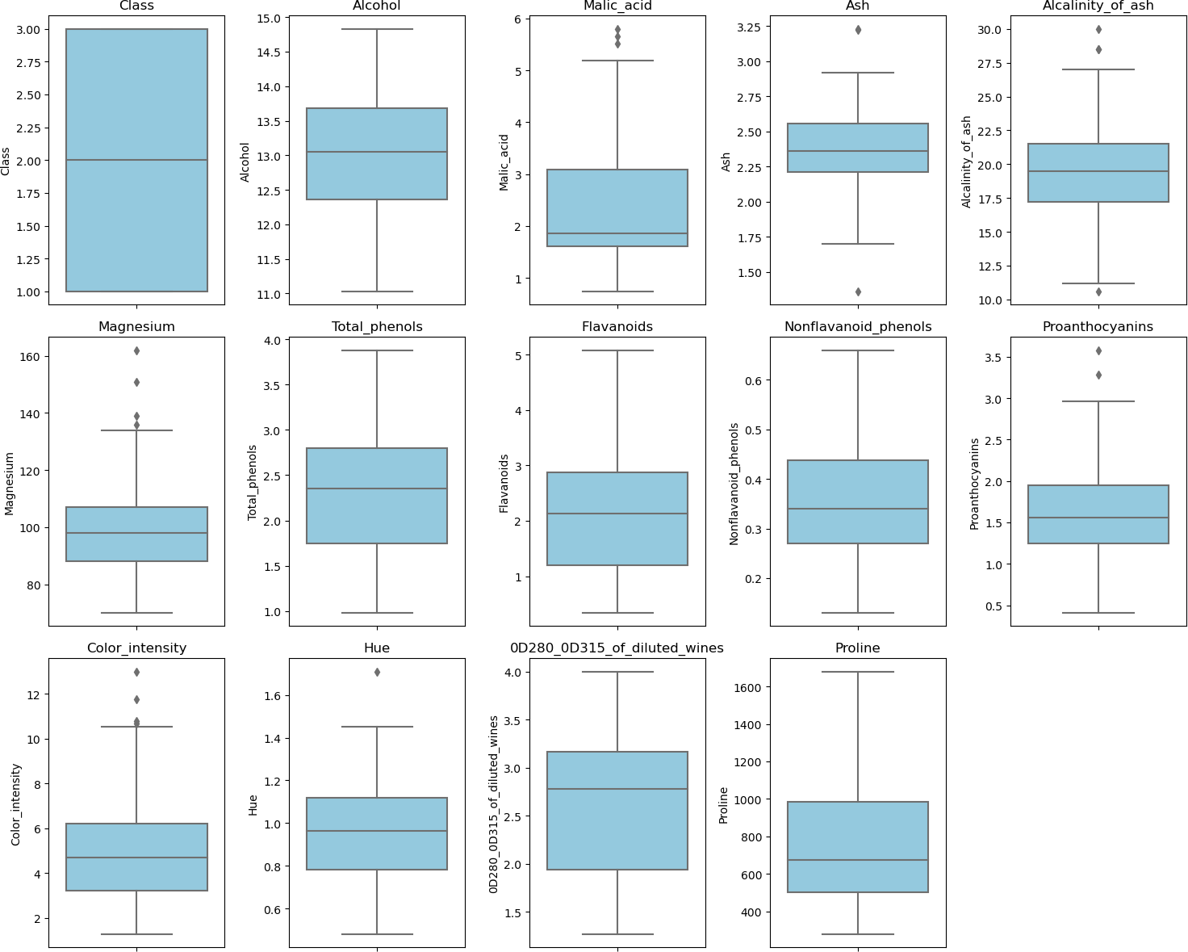

|  |  |  |
| --- | --- | --- |
|  | | **\*As this is a small data set we don't remove outliers here.**  **Selecting feature variables** |
| **In** | **[12]:** | **X = df.drop(['Class'], axis="columns") X.head()** |

|  |  |  |  |  |  |  |  |  |
| --- | --- | --- | --- | --- | --- | --- | --- | --- |
| **Out[12]:** | **Alcohol** | **Malic_acid** | **Ash** | **Alcalinity_of_ash** | **Magnesium** | **Total_phenols** | **Flavanoids** | **Nonflavano** |
|  | **0 14.23** | **1.71** | **2.43** | **15.6** | **127** | **2.80** | **3.06** |  |
|  | **1 13.20** | **1.78** | **2.14** | **11.2** | **100** | **2.65** | **2.76** |  |
|  | **2 13.16** | **2.36** | **2.67** | **18.6** | **101** | **2.80** | **3.24** |  |
|  | **3 14.37** | **1.95** | **2.50** | **16.8** | **113** | **3.85** | **3.49** |  |
|  | **4 13.24** | **2.59** | **2.87** | **21.0** | **118** | **2.80** | **2.69** |  |

**Selecting target variables**

In [13]:

y = df['Class']

y.head()

Out[13]:

***#show the correlation matrix and the correlation matrix with the range of -0.75 to***

correlation_matrix_1 = X.corr()

correlation_matrix_2 = correlation_matrix_1[(correlation_matrix_1>0.75) | (correlat

fig, axes = plt.subplots(nrows=1, ncols=2, figsize=(20, 10)) axes = axes.flatten()

sns.heatmap(correlation_matrix_1, annot=True, cmap='coolwarm', square=True , ax=ax axes[0].set_title('Correlation Matrix (Full)')

sns.heatmap(correlation_matrix_2, annot=True, cmap='coolwarm', square=True , ax=ax axes[1].set_title('Correlation Matrix (range of -0.75 to 0.75)')

In [14]:

**0 1**

|  |  |
| --- | --- |
| **1** | **1** |
| **2** | **1** |
| **3** | **1** |
| **4** | **1** |

Name: Class, dtype: int64

# Check for multicollinearity

Out[14]:

Text(0.5, 1.0, 'Correlation Matrix (range of -0.75 to 0.75)')

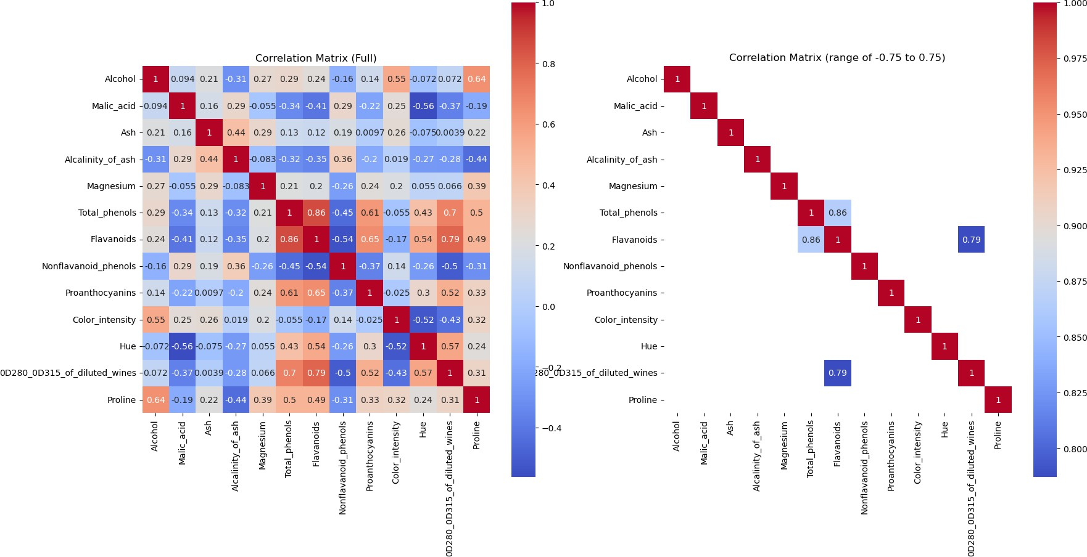

**By considering above heat map we can see some of the features are correlated with each other. So let's remove one of the feature column in higherly correlated pair.**

**Let's set the threshold to 0.75 remove**  **Total_phenols and**

**0D280_0D315_of_diluted_wines feature columns to avoid multicolinerity. Dropping correlated variable**

In [15]:

X = X.drop(['0D280_0D315_of_diluted_wines','Total_phenols'], axis=1) X.head()

|  |  |  |  |  |  |  |  |  |
| --- | --- | --- | --- | --- | --- | --- | --- | --- |
| **Out[15]:** | **Alcohol** | **Malic_acid** | **Ash** | **Alcalinity_of_ash** | **Magnesium** | **Flavanoids** | **Nonflavanoid_phenols** | **Pro** |
|  | **0 14.23** | **1.71** | **2.43** | **15.6** | **127** | **3.06** | **0.28** |  |
|  | **1 13.20** | **1.78** | **2.14** | **11.2** | **100** | **2.76** | **0.26** |  |
|  | **2 13.16** | **2.36** | **2.67** | **18.6** | **101** | **3.24** | **0.30** |  |
|  | **3 14.37** | **1.95** | **2.50** | **16.8** | **113** | **3.49** | **0.24** |  |
|  | **4 13.24** | **2.59** | **2.87** | **21.0** | **118** | **2.69** | **0.39** |  |

# Check the Confusion Matrix after dropping correlated features

correlation_matrix_1 = X.corr()

correlation_matrix_2 = correlation_matrix_1[(correlation_matrix_1>0.75) | (correlat

fig, axes = plt.subplots(nrows=1, ncols=2, figsize=(20, 10)) axes = axes.flatten()

sns.heatmap(correlation_matrix_1, annot=True, cmap='coolwarm', square=True , ax=ax axes[0].set_title('Correlation Matrix (Full)')

sns.heatmap(correlation_matrix_2, annot=True, cmap='coolwarm', square=True , ax=ax axes[1].set_title('Correlation Matrix (range of -0.75 to 0.75)')

In [16]:

Out[16]:

Text(0.5, 1.0, 'Correlation Matrix (range of -0.75 to 0.75)')

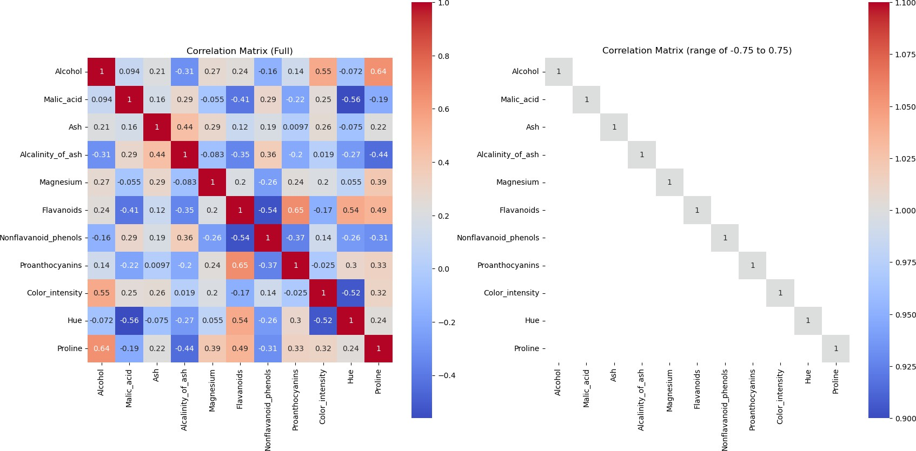

# Standardizing data using StandardScaler

In [17]:

scaler = StandardScaler()

X_scaled = scaler.fit_transform(X)

# Splitting training data and testing data

In [18]:

X_train, X_test, y_train, y_test = train_test_split(X_scaled, y, test_size=0.2, ra

In [19]:

print("Number of data that is used to train : ",len(X_train)) print("Number of data that is used to test : ",len(X_test))

Number of data that is used to train : 142 Number of data that is used to test : 36

# display and store each accuracy value for corresponding k value

***# train KNN for different K values 0 - 20***

k_values = range(1,21)

***# store each accuracy value for corresponding k value***

accuracies = []

for k in k_values:

knn = KNeighborsClassifier(n_neighbors=k) knn.fit(X_train, y_train)

y_pred = knn.predict(X_test)

accuracy = accuracy_score(y_test, y_pred)

print("accuracy score at k = ",k," : ",accuracy) accuracies.append(accuracy)

In [20]:

|  |  |  |  |  |  |  |
| --- | --- | --- | --- | --- | --- | --- |
| **accuracy** | **score** | **at** | **k** | **=** | **1 :** | **0.9444444444444444** |
| **accuracy** | **score** | **at** | **k** | **=** | **2 :** | **0.9444444444444444** |
| **accuracy** | **score** | **at** | **k** | **=** | **3 :** | **0.9444444444444444** |
| **accuracy** | **score** | **at** | **k** | **=** | **4 :** | **0.9444444444444444** |
| **accuracy** | **score** | **at** | **k** | **=** | **5 :** | **0.9444444444444444** |
| **accuracy** | **score** | **at** | **k** | **=** | **6 :** | **0.9444444444444444** |
| **accuracy** | **score** | **at** | **k** | **=** | **7 :** | **0.9444444444444444** |
| **accuracy** | **score** | **at** | **k** | **=** | **8 :** | **0.9722222222222222** |
| **accuracy** | **score** | **at** | **k** | **=** | **9 :** | **0.9444444444444444** |
| **accuracy** | **score** | **at** | **k** | **=** | **10 :** | **0.9722222222222222** |
| **accuracy** | **score** | **at** | **k** | **=** | **11 :** | **0.9722222222222222** |
| **accuracy** | **score** | **at** | **k** | **=** | **12 :** | **0.9722222222222222** |
| **accuracy** | **score** | **at** | **k** | **=** | **13 :** | **0.9722222222222222** |
| **accuracy** | **score** | **at** | **k** | **=** | **14 :** | **0.9722222222222222** |
| **accuracy** | **score** | **at** | **k** | **=** | **15 :** | **0.9444444444444444** |
| **accuracy** | **score** | **at** | **k** | **=** | **16 :** | **0.9722222222222222** |
| **accuracy** | **score** | **at** | **k** | **=** | **17 :** | **0.9444444444444444** |
| **accuracy** | **score** | **at** | **k** | **=** | **18 :** | **0.9722222222222222** |
| **accuracy** | **score** | **at** | **k** | **=** | **19 :** | **0.9722222222222222** |
| **accuracy** | **score** | **at** | **k** | **=** | **20 :** | **0.9722222222222222** |

plt.figure(figsize=(10,6))

plt.plot(k_values, accuracies, marker='o', linestyle='--') plt.xlabel('K-Value')

plt.ylabel('Accuracy') plt.show()

In [21]:

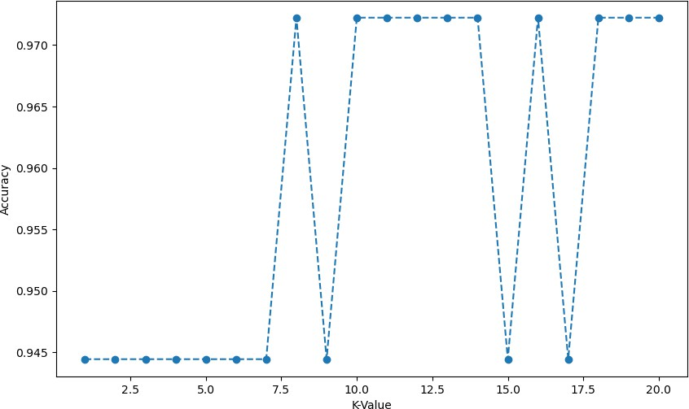

# Find the best K value

In [22]:

best_k_val = k_values[accuracies.index(max(accuracies))] best_accuracy = max(accuracies)

print(f"Best value for k: {best_k_val} with accuracy: {best_accuracy:.2f}")

Best value for k: 8 with accuracy: 0.97

# Initialize the K-NN model with best k value

In [23]:

knn_model = KNeighborsClassifier(n_neighbors=best_k_val)

knn_model.fit(X_train, y_train)

Out[23]:

**KNeighborsClassifier(n_neighbors=8)**

**▾ KNeighborsClassifier**

In [24]:

y_pred = knn_model.predict(X_test)

# Classification Report

In [25]:

print(classification_report(y_test, y_pred))

|  |  |  |  |
| --- | --- | --- | --- |
| **precision** | **recall** | **f1-score** | **support** |
| **1 0.93** | **1.00** | **0.97** | **14** |
| **2 1.00** | **0.93** | **0.96** | **14** |
| **3 1.00** | **1.00** | **1.00** | **8** |
| **accuracy** |  | **0.97** | **36** |
| **macro avg** **0.98** | **0.98** | **0.98** | **36** |
| **weighted avg** **0.97** | **0.97** | **0.97** | **36** |
| **Confusion matrix** |  |  |  |

In [26]:

conf_matrix = confusion_matrix(y_test, y_pred)

display = ConfusionMatrixDisplay(conf_matrix, display_labels=knn.classes_) display.plot(cmap='Blues', values_format='d')

plt.title('Confusion Matrix') plt.xlabel('Predicted')

plt.ylabel('Actual') plt.show()

